**Struts 2 Application Step by Step in Eclipse**

**Step 1:**

Download and install strut2 on your machine as shown in below steps

1. Download the latest version of Struts2 binaries from <https://struts.apache.org/download.cgi>.
2. Make the proper choice whether windows, unix or mac os
3. Download Full Distribution:[struts-2.5.20-all.zip](http://mirrors.estointernet.in/apache/struts/2.5.20/struts-2.5.20-all.zip)
4. Unzip the downloaded file it will give you directory structure inside C:\struts-2.2. 3 as follows.

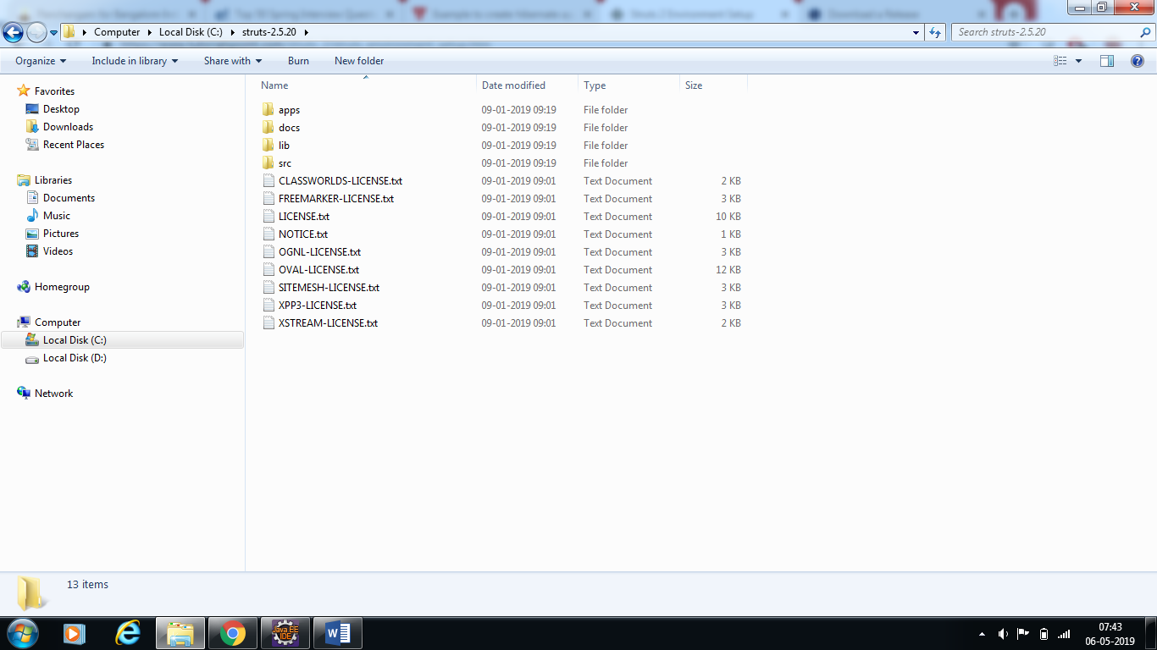

**Step 2:**

Create a dynamic web project as shown below

a) 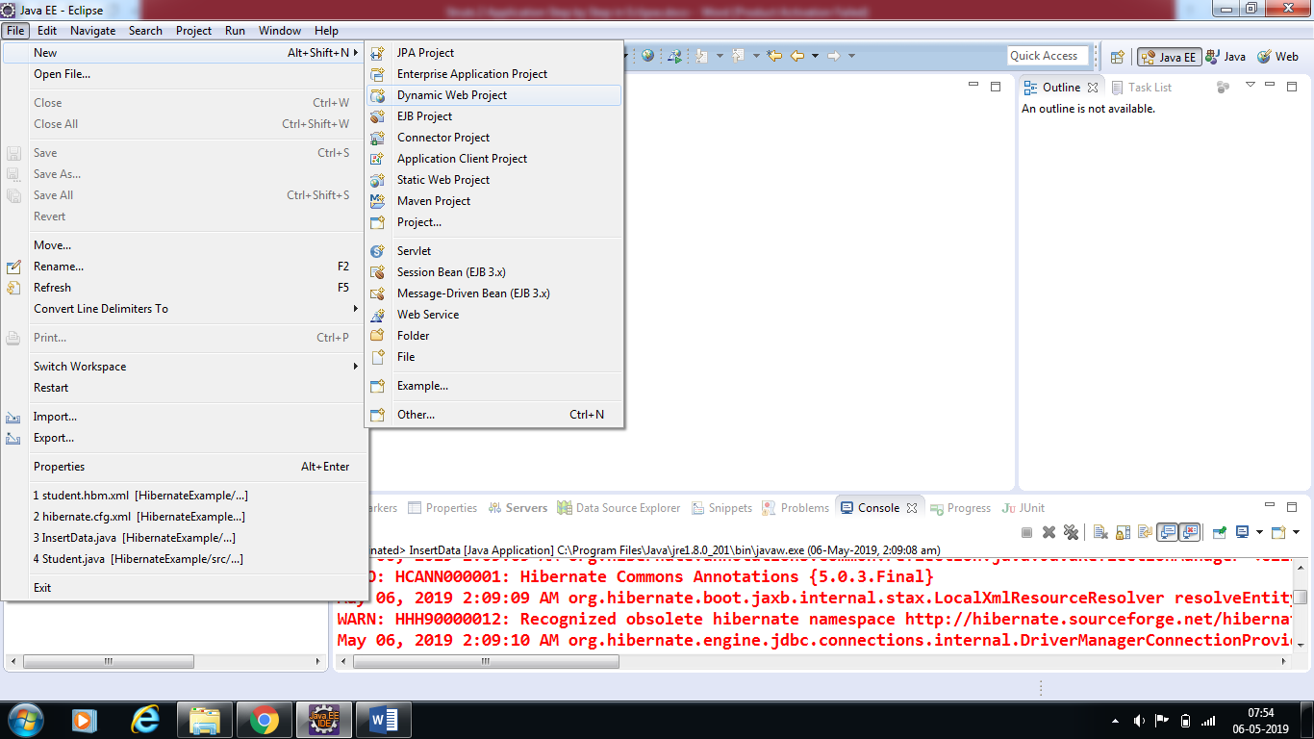

b) Name the project as shown below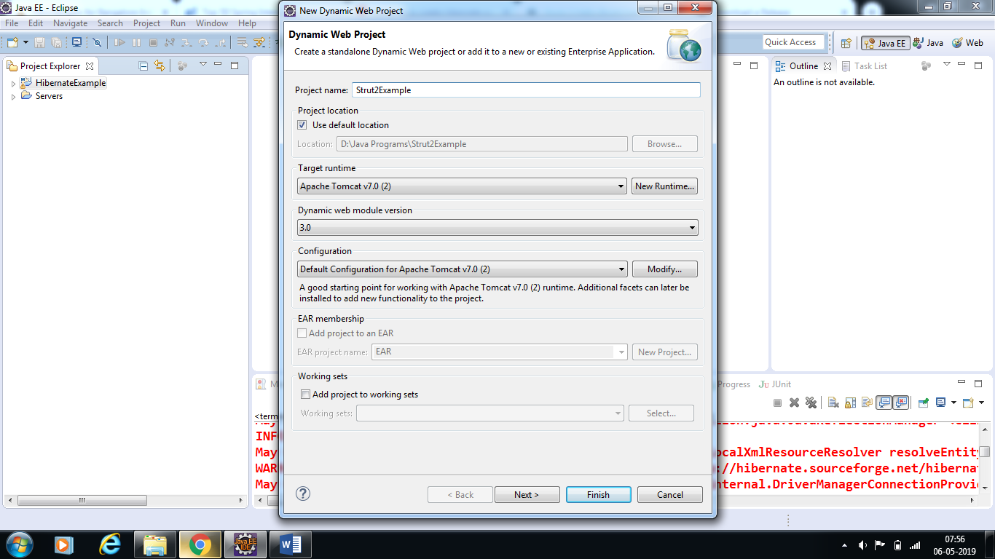

c)Click next



d) Click next

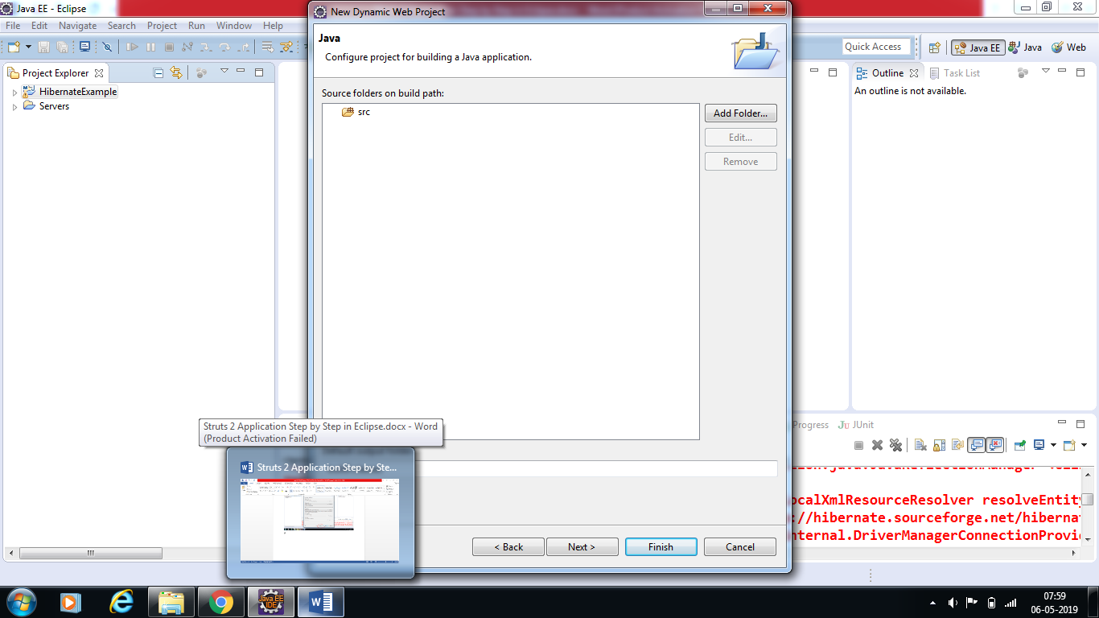

e) Tick the check box to Generate Deployment Descriptor and click finish

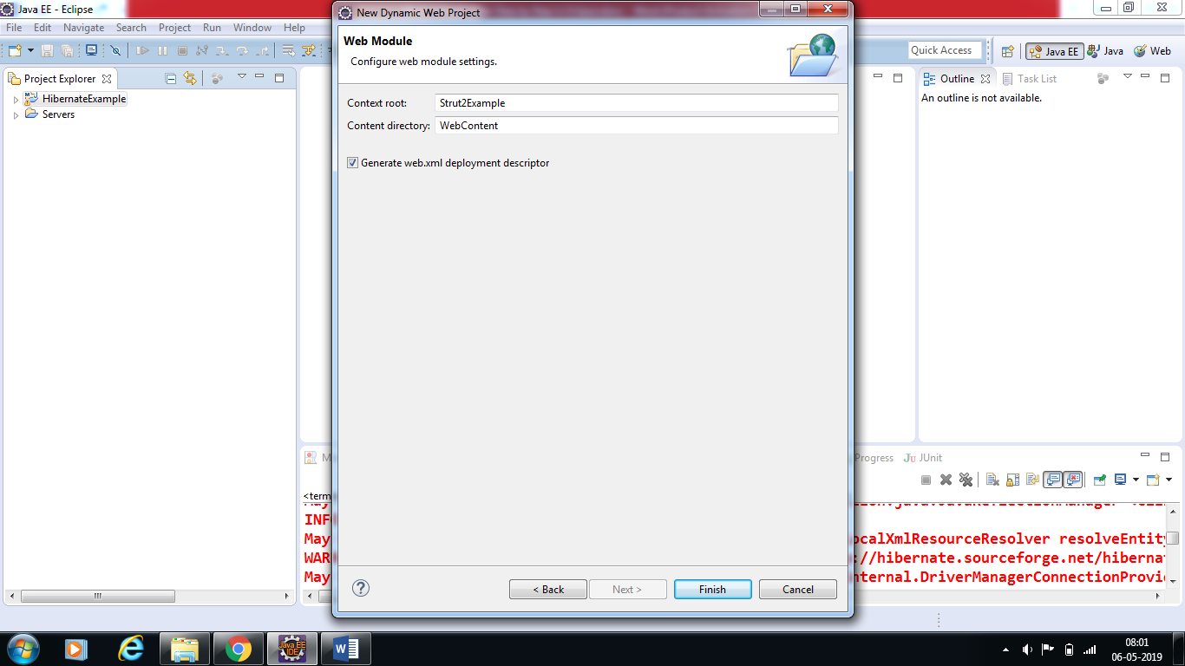

f) Package structure after successful creation of the project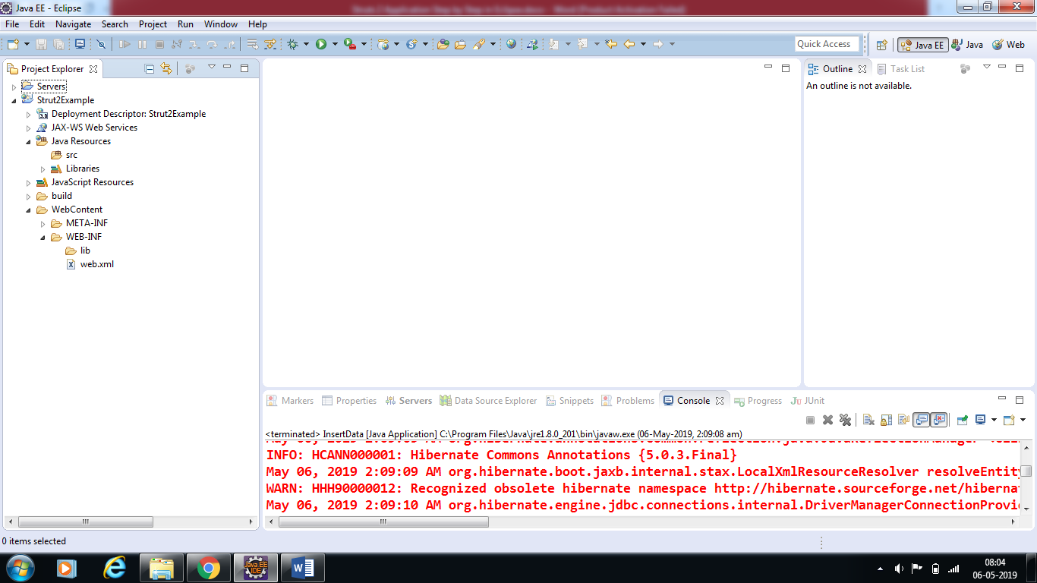

**Step 3:**

Now copy following files from struts 2 lib folder **C:\struts-2.5.20\lib** to our project's **WEB-INF\lib** folder as shown below

a)

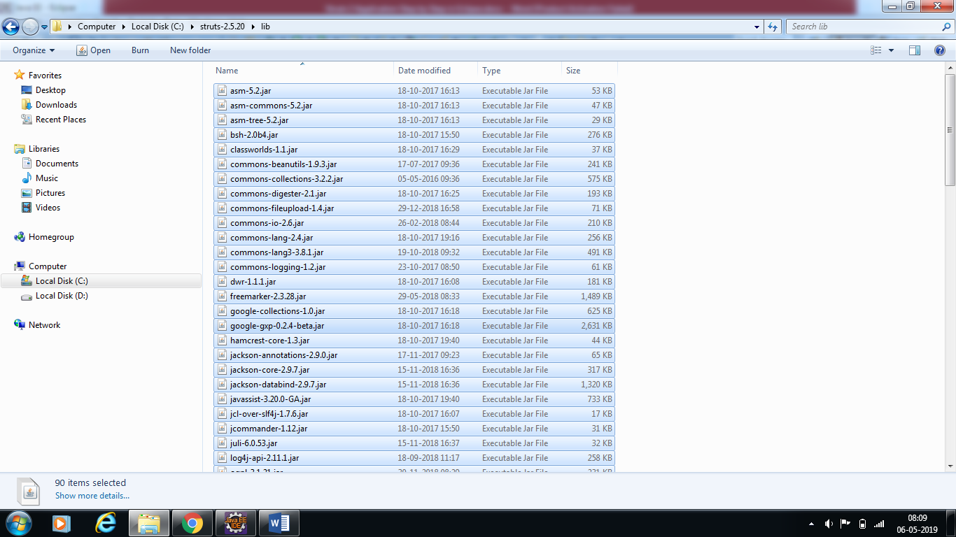

b) Copy all files

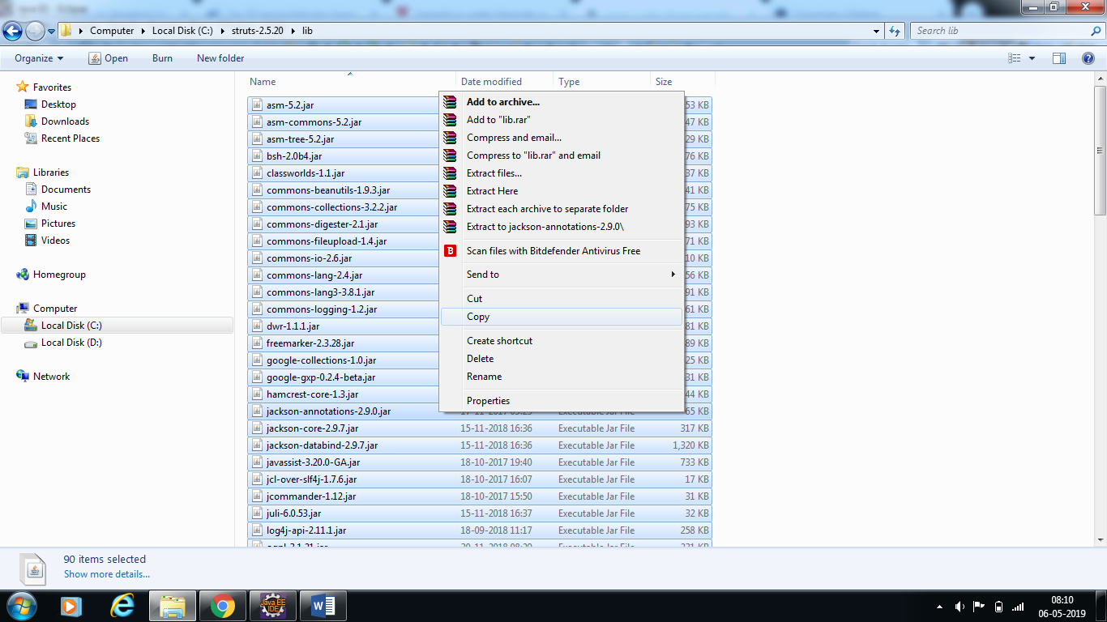

c) Paste all files in lib folder of project structure

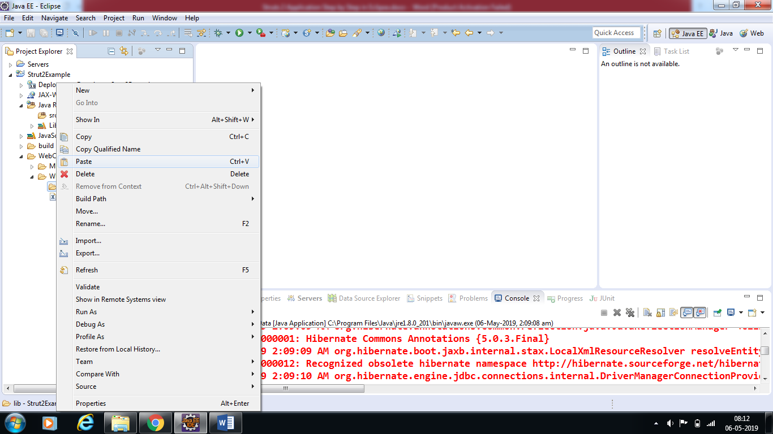

d) Project structure

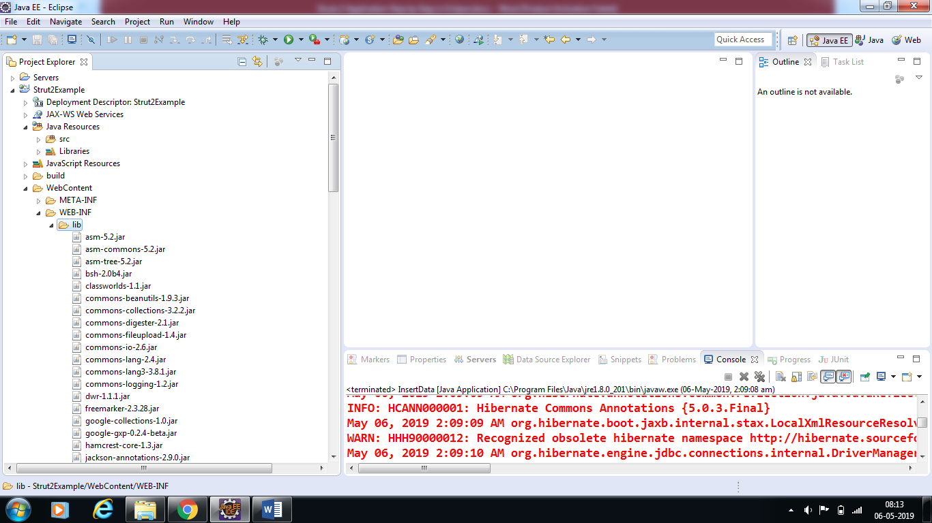

**Step 4:**

**Create Action Class**

Action class is the key to Struts 2 application and we implement most of the business logic in action class. So let us create a java file ***HelloWorldAction.java*** under ***JavaResources->src*** with a package name ***com.helpism.struts*** with the contents given below

*The Action class responds to a user action when user clicks a URL. One or more of the Action class's methods are executed and a String result is returned. Based on the value of the result, a specific JSP page is rendered.*

a) 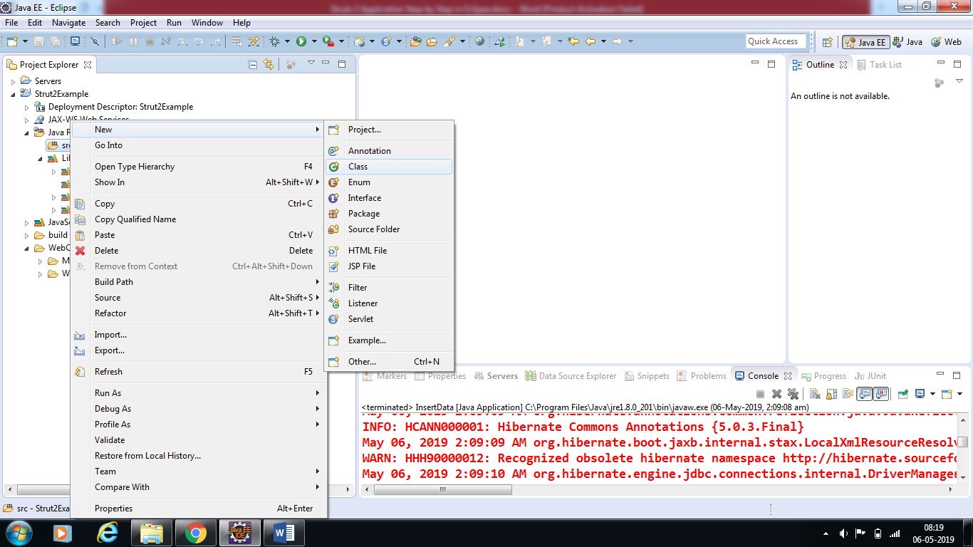

b)

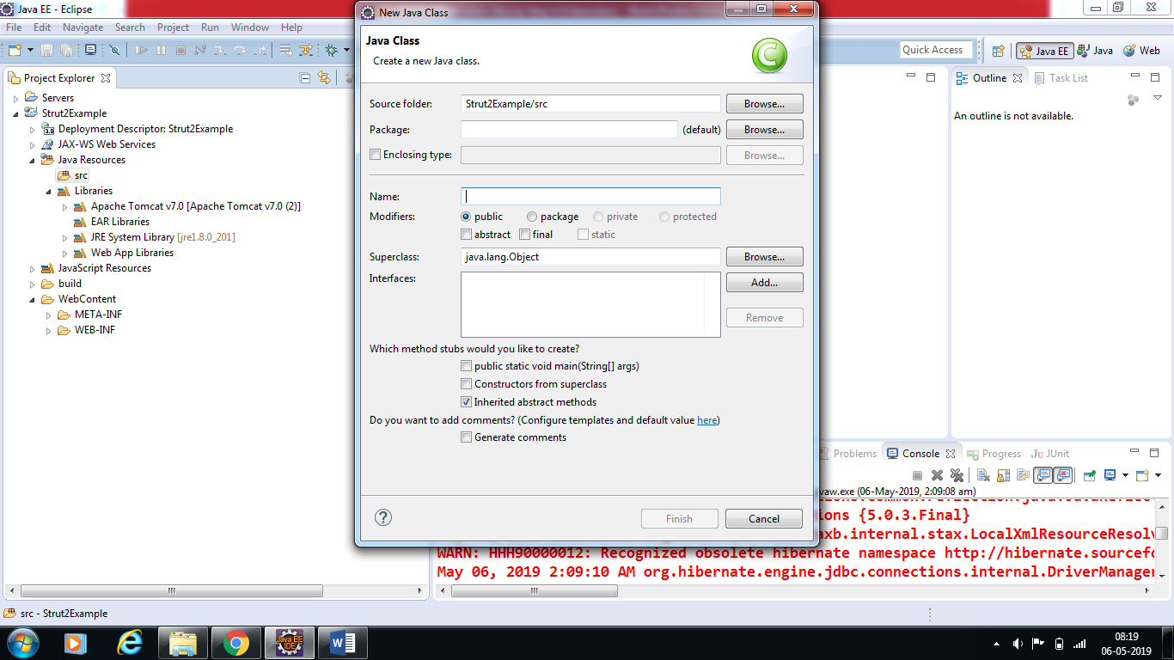

c) Enter the package name and class name as shown below and click on finish

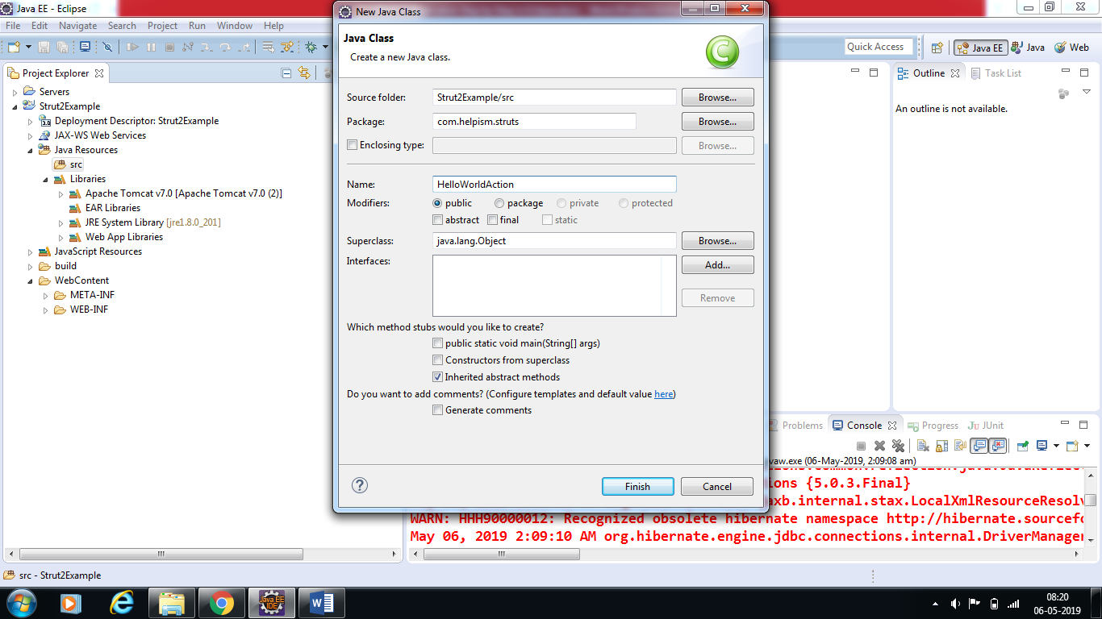

d) Paste the following code of ***HelloWorldAction.java*** in the below created class (download the sample code of struts from google class room)

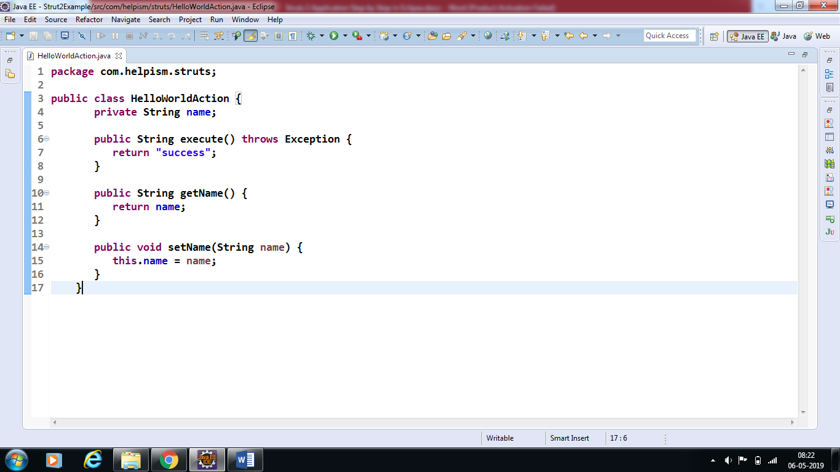

**Step 5:**

## Create a View

Let us create the below jsp file ***HelloWorld.jsp*** in the ***WebContent***folder in your eclipse project. To do this, right click on the ***WebContent*** folder in the project explorer and select ***New ->JSP*** File.

*We need a JSP to present the final message, this page will be called by Struts 2 framework when a predefined action will happen and this mapping will be defined in struts.xml file.*

1. Select jsp file

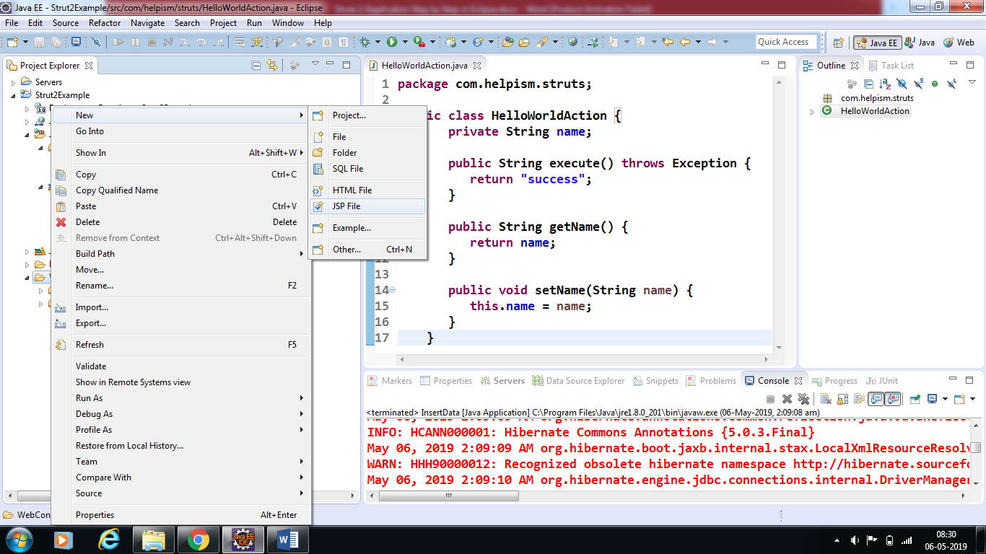

b) Enter the Name of the jsp and click next and then click finish

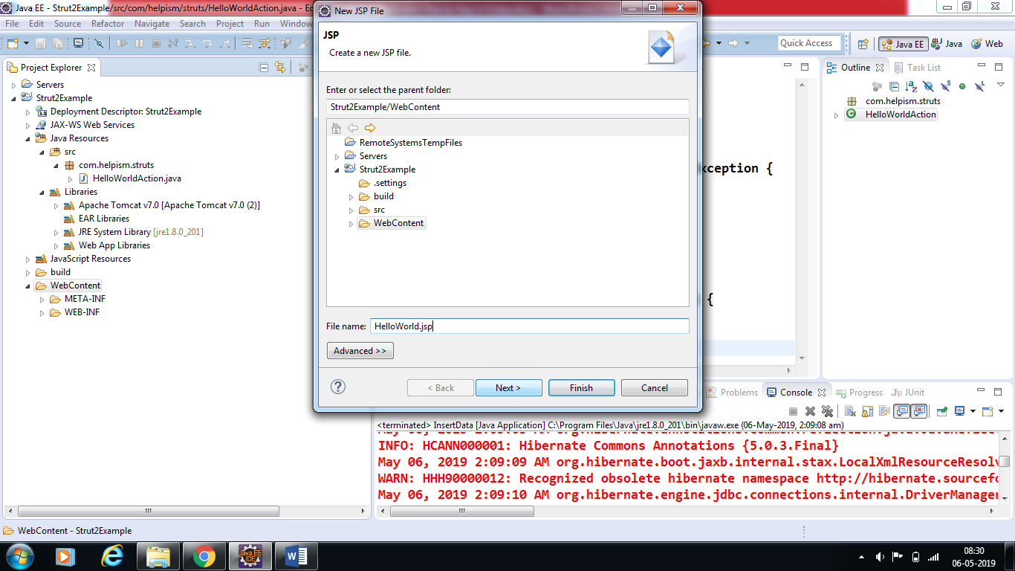

c) Paste the following code(HelloWorld.jsp code from downloaded code) in the created jsp file

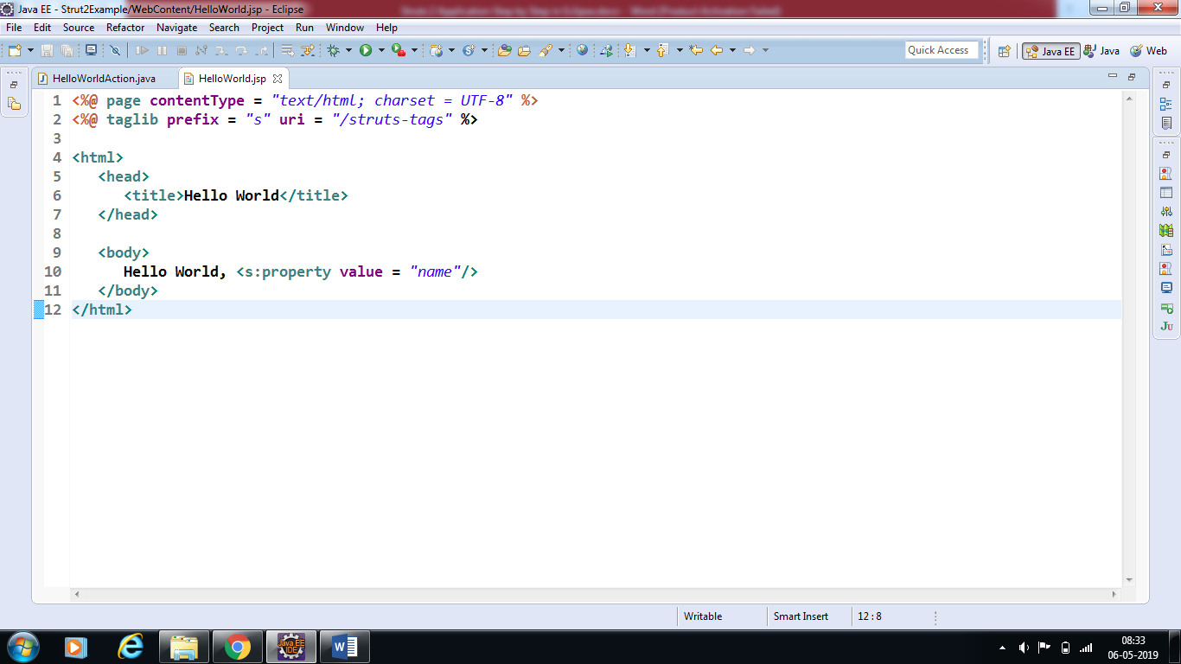

*The taglib directive tells the Servlet container that this page will be using the****Struts 2****tags and that these tags will be preceded by****s****.*

*The s:property tag displays the value of action class property "name> which is returned by the method****getName()****of the HelloWorldAction class.*

**Step 6:**

## Create Main Page

*We also need to create****index.jsp****in the* ***WebContent*** *folder. This file will serve as the initial action URL where a user can click to tell the Struts 2 framework to call a defined method of the* ***HelloWorldAction*** *class and render the* ***HelloWorld.jsp*** *view.*

1. Select jsp file

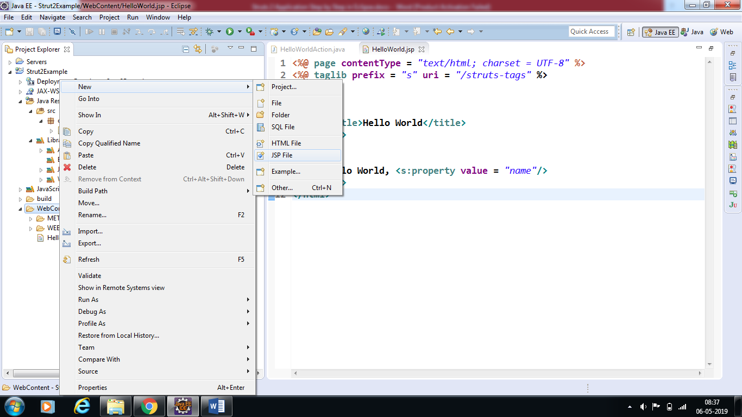

1. Enter the Name of the jsp and click next and then click finish

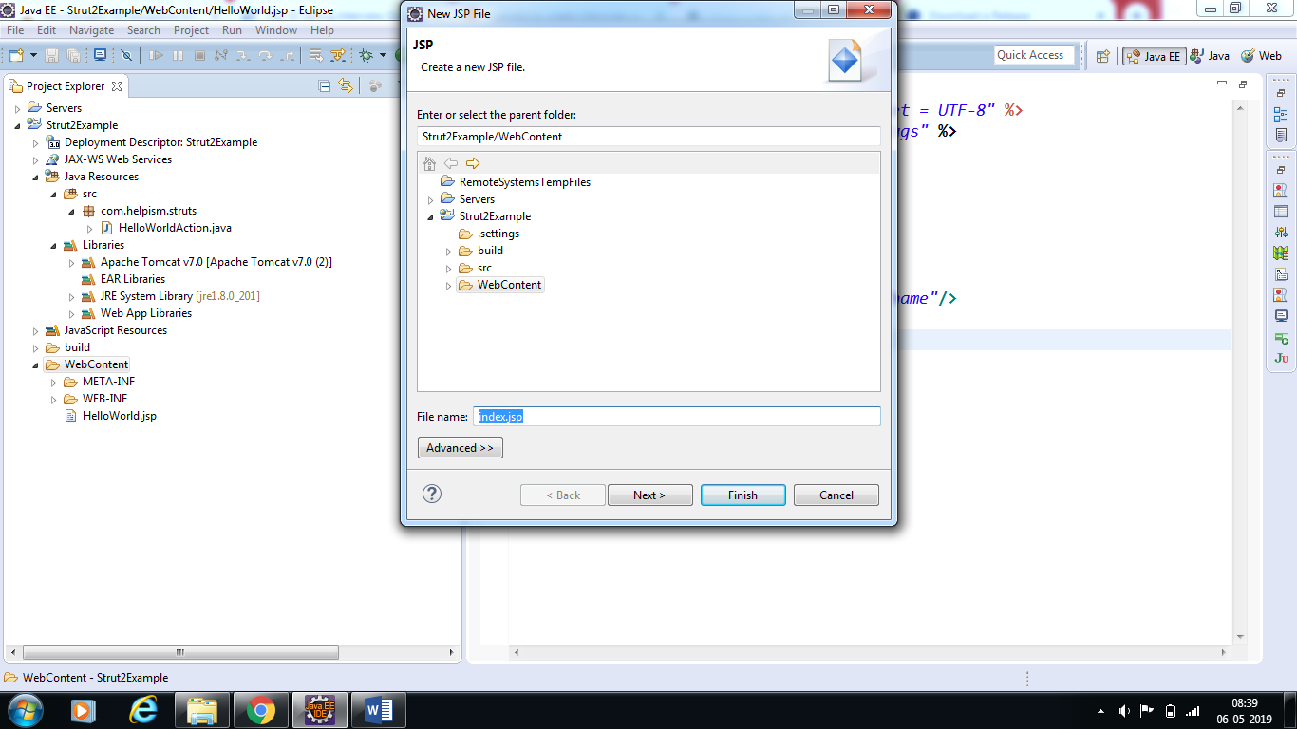

c) Paste the following code (HelloWorld.jsp code from downloaded code) in the created jsp file.

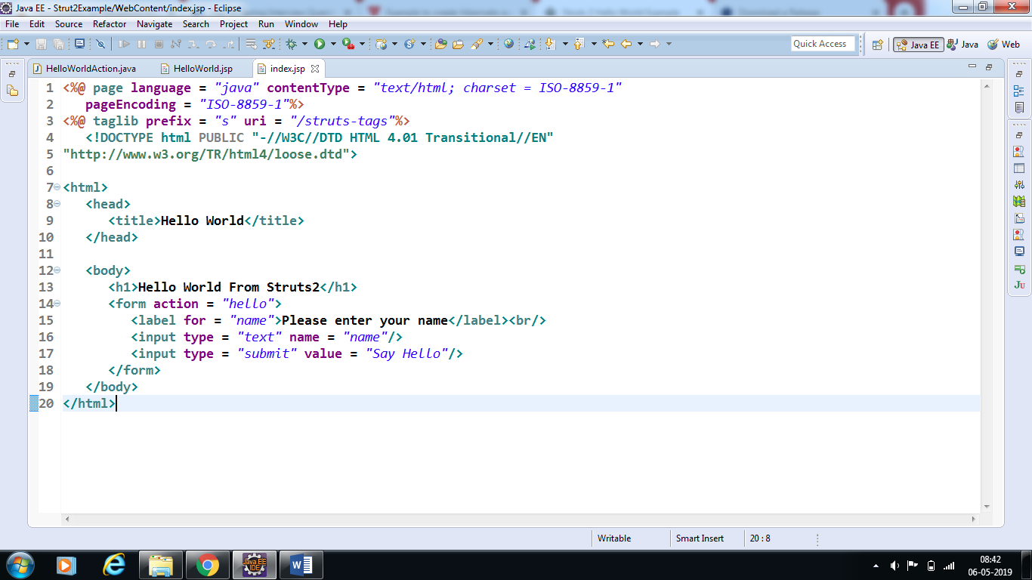

*The* ***hello action*** *defined in the above view file will be mapped to the* ***HelloWorldAction*** *class and its execute method using struts.xml file. When a user clicks on the Submit button it will cause the Struts 2 framework to run the execute method defined in the* ***HelloWorldAction*** *class and based on the returned value of the method, an appropriate view will be selected and rendered as a response.*

**Step 7:**

*We need a mapping to tie the URL, the* ***HelloWorldAction class (Model),*** *and the* ***HelloWorld.jsp (the view)*** *together. The mapping tells the Struts 2 framework which class will respond to the user's action (the URL), which method of that class will be executed, and what view to render based on the String result that method returns.*

*So let us create a file called struts.xml. Since* ***Struts 2 requires struts.xml*** *to be present in the classes folder. Hence, create struts.xml file under the* ***WebContent/WEB-INF/classes folder****. Eclipse does not create the "classes" folder by default, so you need to do this yourself. To do this, right click on the* ***WEB-INF folder*** *in the project explorer and select* ***New > Folder****. Your struts.xml should look like below*

*Following are steps to create* ***struts.xml*** *file*

1. Select Folder Option like below

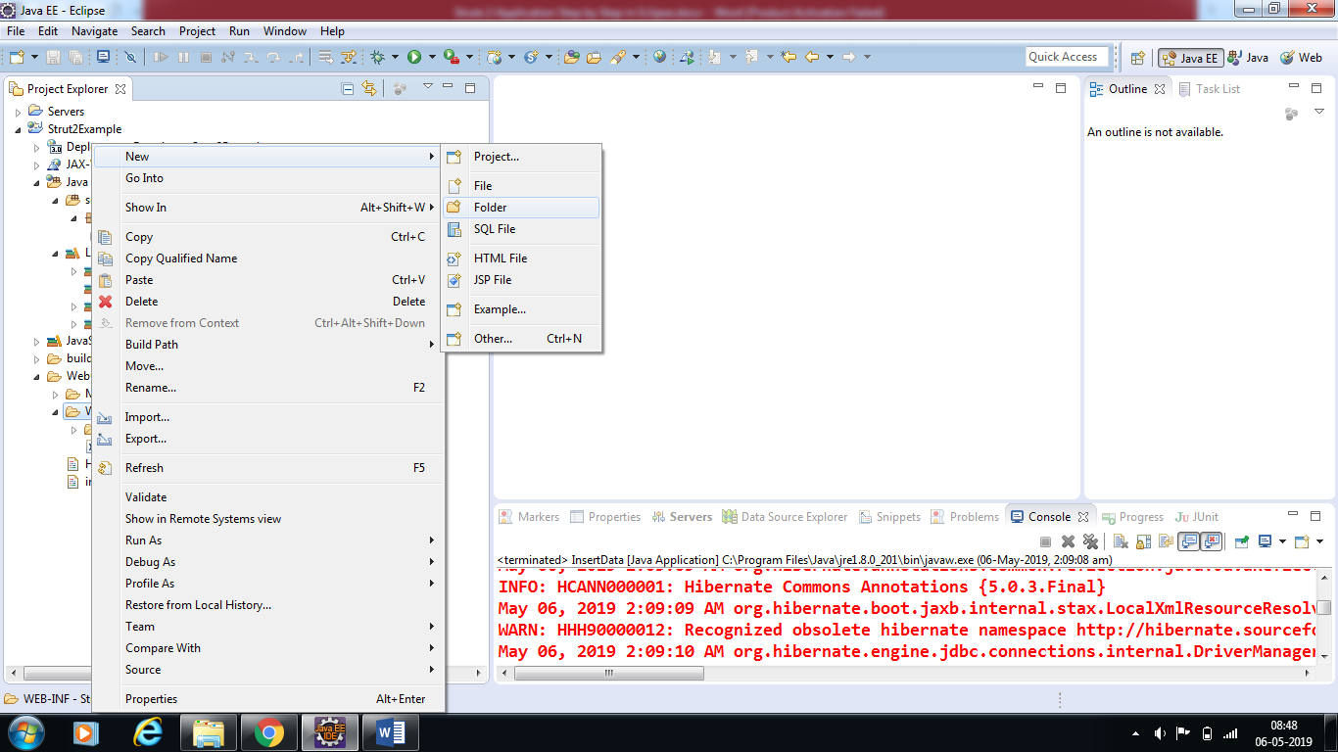

1. Create classes folder as shown below and click finish

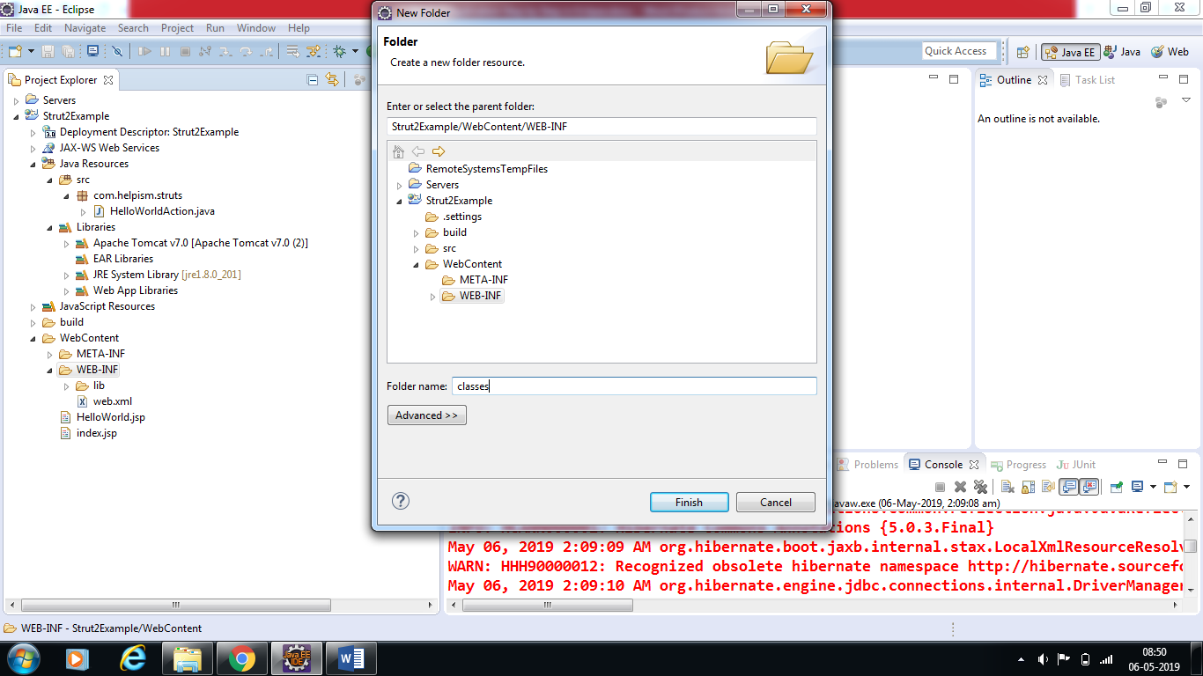

1. Create ***struts.xml*** file under classes folder as shown below

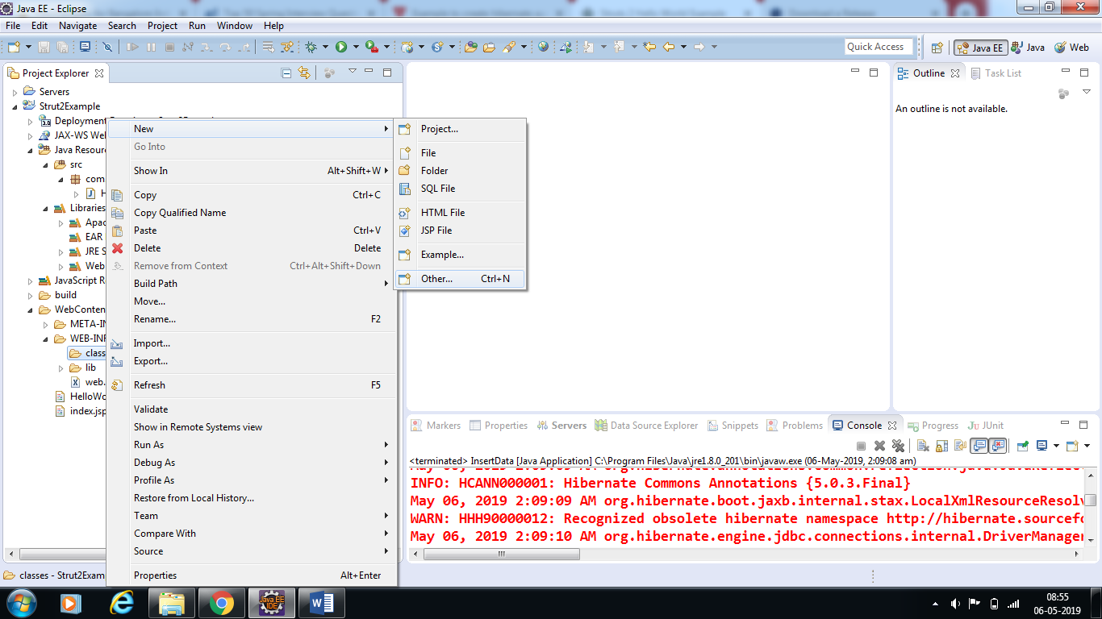

1. Select XML -> XML file and click next

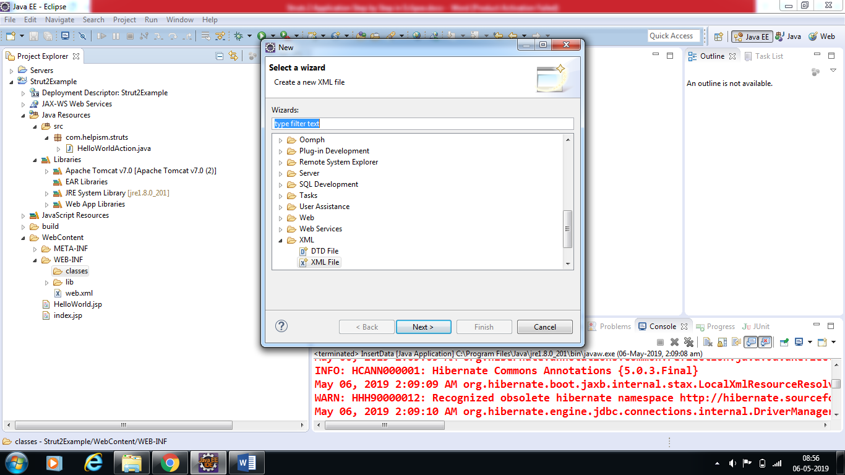

1. Enter the xml file name and click on finish

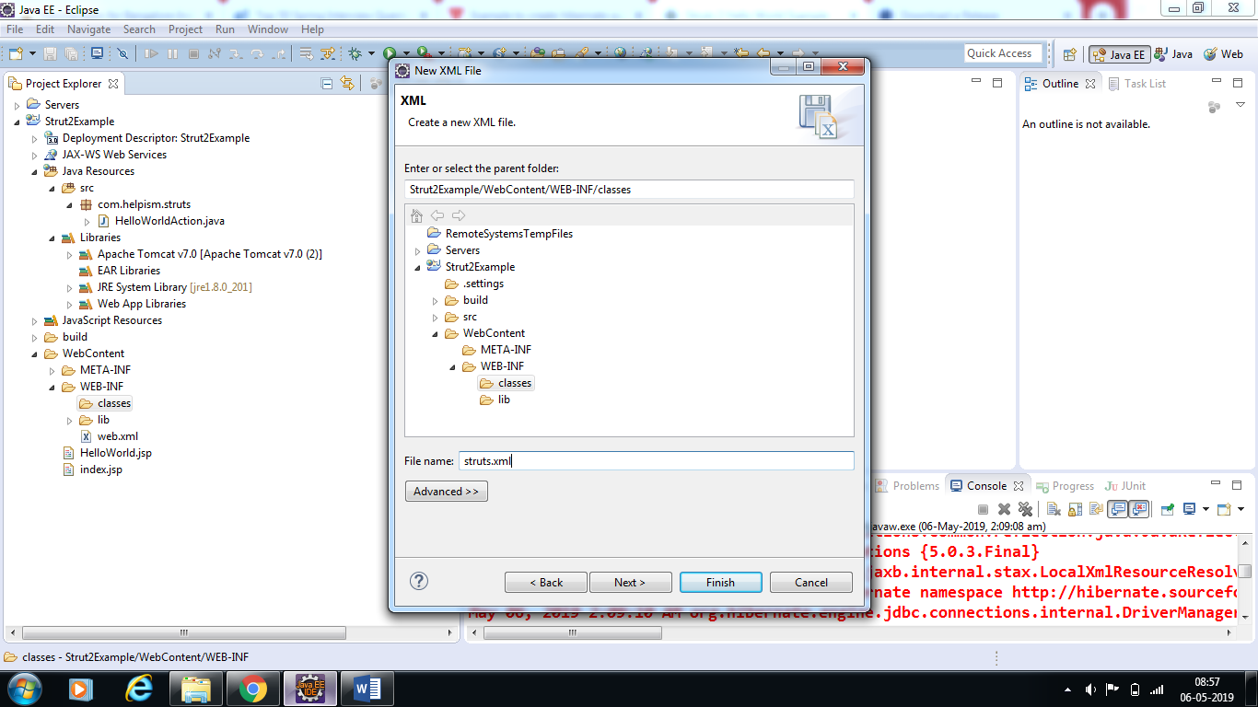

1. Enter the code in xml file

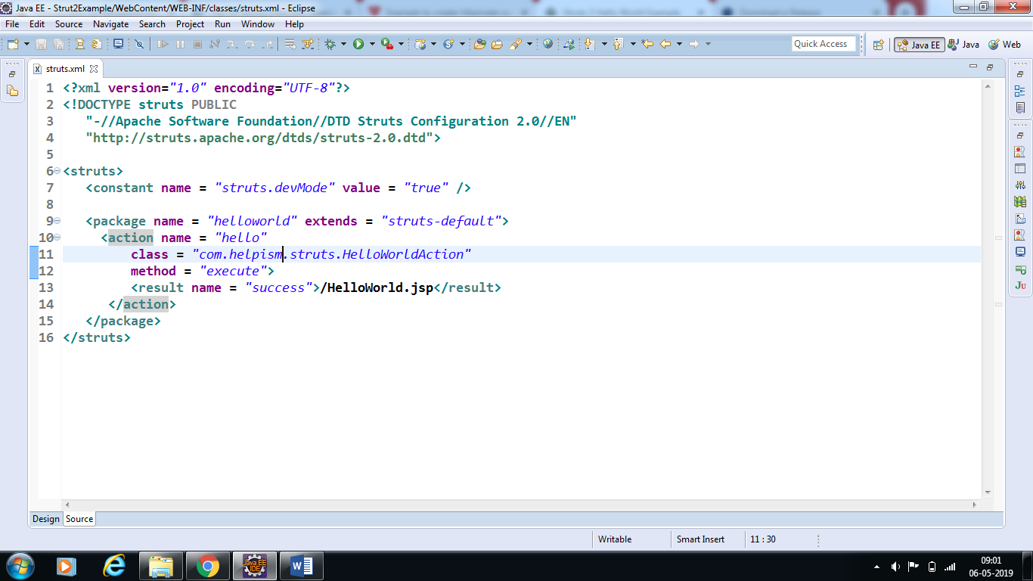

**Step 8:**

Next step is to create a web.xml file which is an entry point for any request to Struts 2. The entry point of Struts2 application will be a filter defined in deployment descriptor (web.xml).

Hence, we will define an entry of ***org.apache.struts2.dispatcher.FilterDispatcher*** class in web.xml.

The **web.xml** file needs to be created under the ***WEB-INF*** folder under ***WebContent***. Eclipse had already created a skeleton web.xml file for you when you created the project. So, lets just modify it as follows

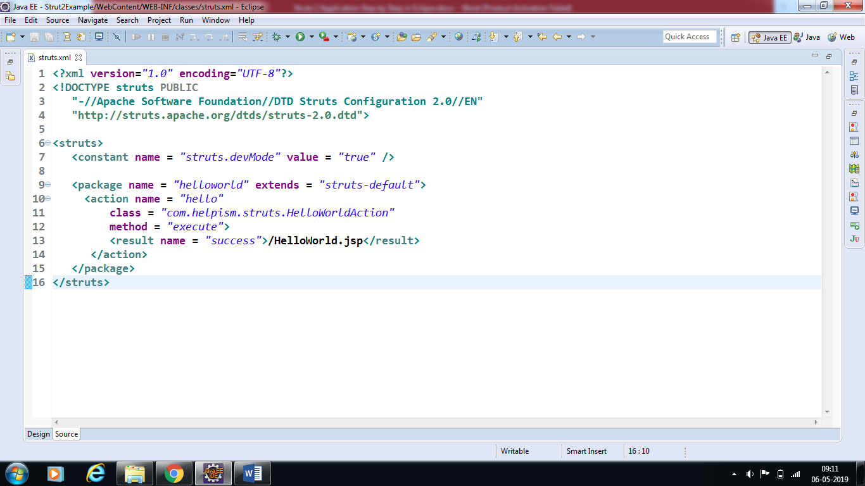

**Step 9:**

## To Enable Detailed Log

*You can enable complete logging functionality while working with Struts 2 by creating****logging.properties****file under****WEB-INF/classes****folder. Keep the following two lines in your property file.*

*The default logging.properties specifies a ConsoleHandler for routing logging to stdout and also a FileHandler. A handler's log level threshold can be set using SEVERE, WARNING, INFO, CONFIG, FINE, FINER, FINEST or ALL*

Follow the below steps to create properties file

1. Create a **logging.properties** file inside c**lasses** folder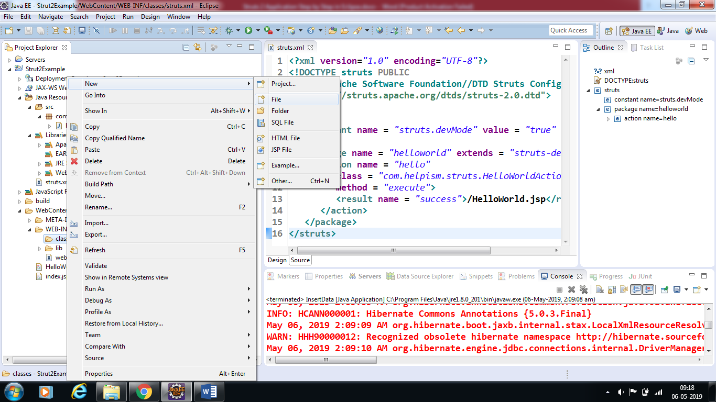
2. Enter the file name and click finish

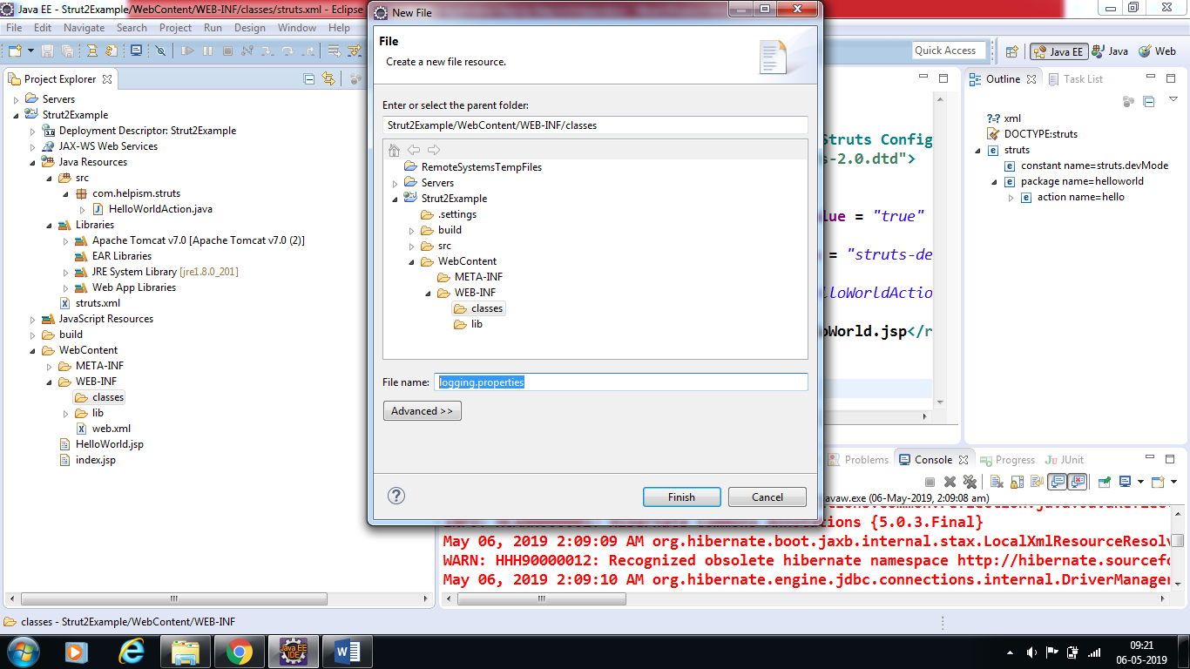

C) add following lines to the file

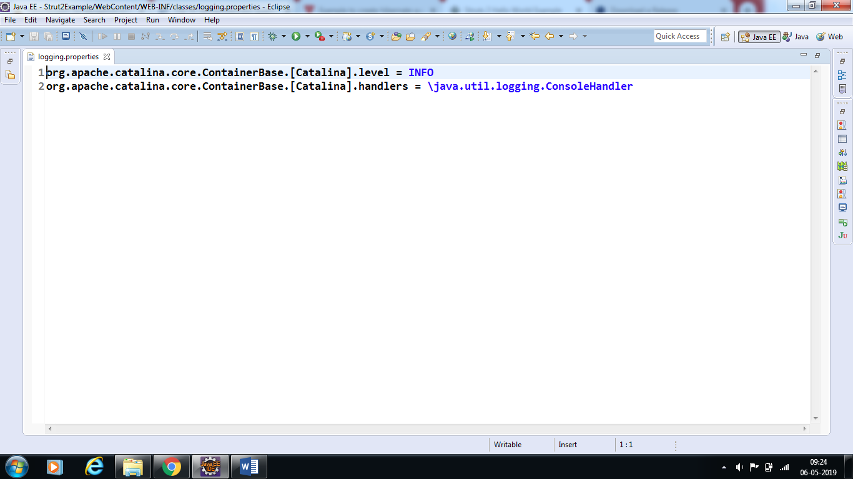

That's it. We are ready to run our Hello World application using Struts 2 framework.

**Step 10:**

## Procedure for Executing the Application

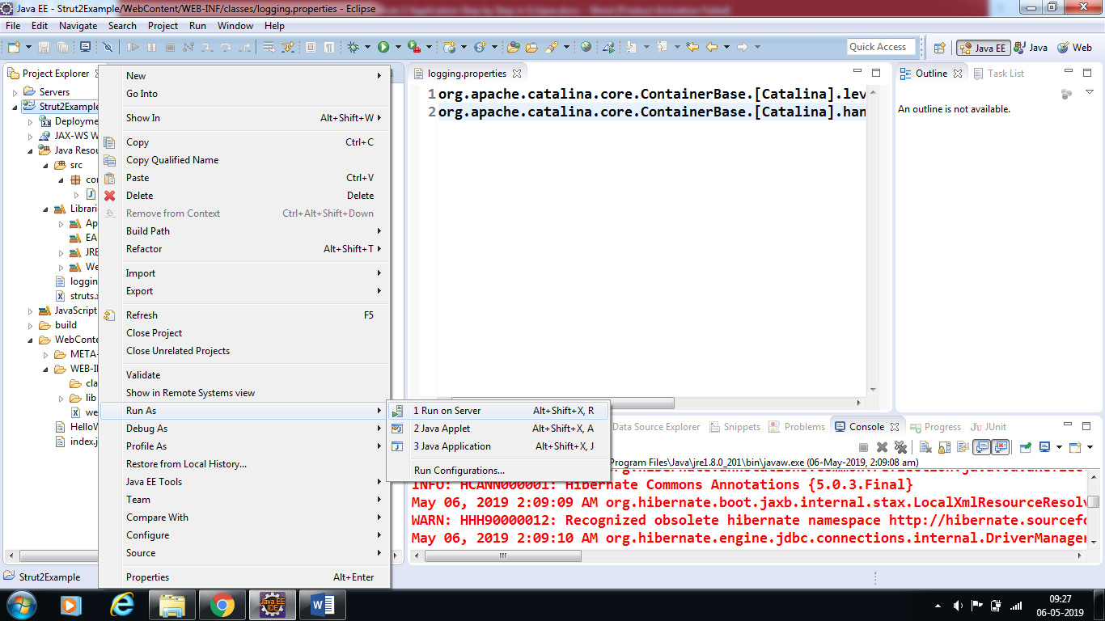

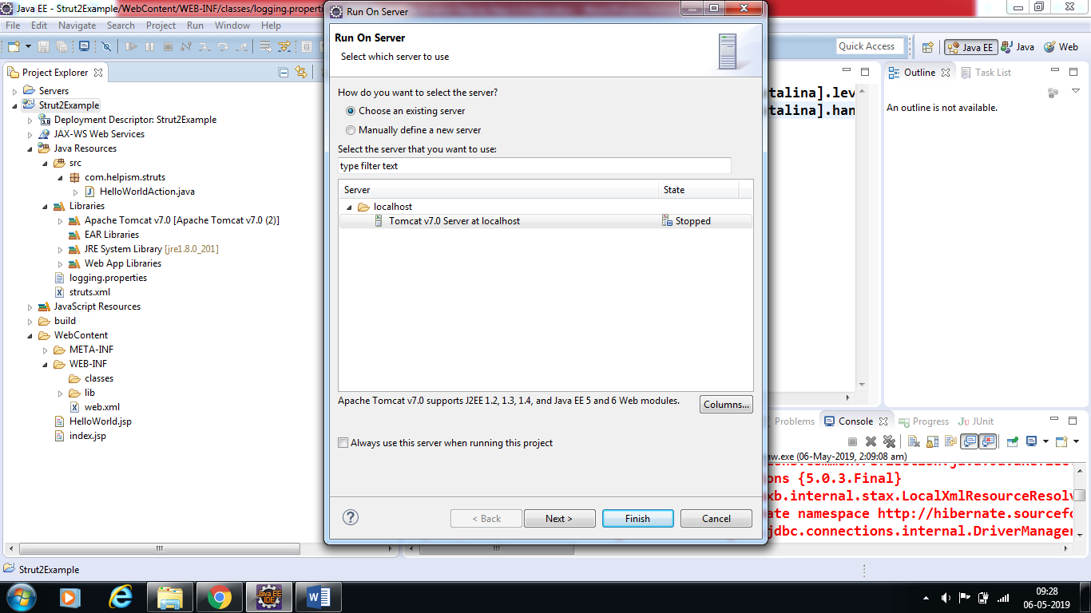

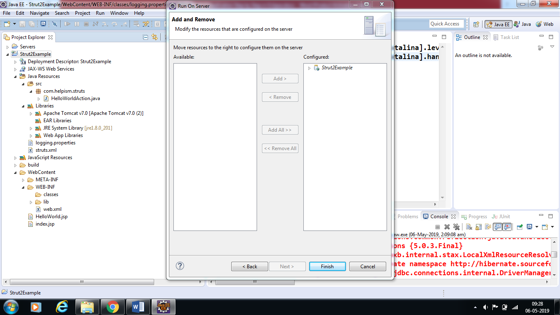

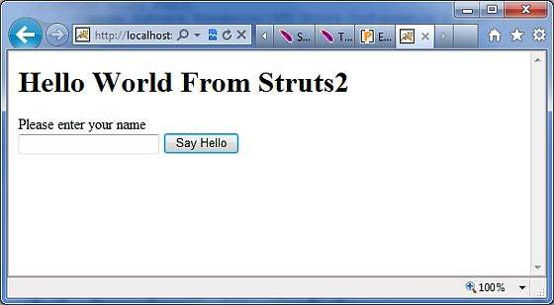

Enter name as “Struts2”in text box

